

**Baldivis Secondary College 2020**

Year 11 Mathematics Specialist

Test 1B

**Name: Time:45 minutes Total / 40**

**INSTRUCTIONS:**

**Calculator allowed**

**Notes allowed – 1 A4 page**

**Full working must be shown for all questions (or parts) worth more than 2 marks.**

**Marks will be deducted for rounding and unit errors.**

**Question 1 [ 1 , 1 = 2 marks ]**

21 items are to be split into 5 boxes. Find the value of *n* if

1. There will be at least one box with no more than *n* items
2. There will be at least one box with at least *n* items

**Question 2 [ 3 marks ]**

|  |
| --- |
| There are 25 students who play in at least one of the three sporting teams - tennis, cricket and soccer. There are 12 students in the cricket team, 13 in the soccer team and 10 in the tennis team. If five students play cricket and soccer, six play cricket and tennis and four play soccer and tennis, how many students are in all three teams? |

**Question 3 [ 4 marks ]**

The English Club has 15 members and the Maths Club has 20 members. There is only one member common to both clubs. In how many ways can a committee of 5 people be formed with at least one member from each club?

**Question 4 [ 4 marks ]**

Two forces have magnitude 5 N and 13 N and the angle between them is 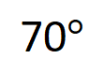. Find the magnitude of the resultant and the angle it makes with the smaller of the two forces.

**Question 5 [ 7 marks ]**

A cyclist travels 3.8 km on a bearing of 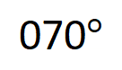 before stopping for a rest. She then continues on for another 6 km on a bearing of 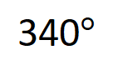 followed by the last 1.2 km on a bearing of 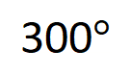 .

Draw a diagram illustrating the situation. Find the distance and bearing of her final position from her initial position.

**Question 6 [ 2, 2, 3, 2 = 9 marks ]**

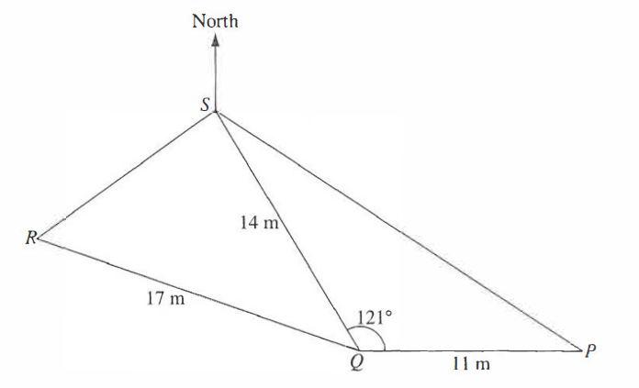

*P, Q, R,* and *S* are four points on ground level. *P* is due East of *Q*. The bearing of *R* from *S* is 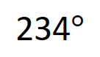 .

Given that 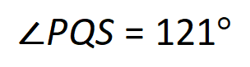, *PQ* = 11 m, *QR* = 17 m and *QS* = 14 m, calculate

1. *PS*
2. 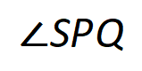
3. 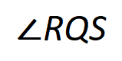
4. The shortest distance from *R* to *QS*

**Question 7 [ 2, 3, 2, 2, 2 = 11 marks ]**

*A, B, C* and *D* are four towns. *B, C* and *D* lie on a straight line with *C* between *B* and *D*. *B* is 3.7 km due South of *A*. The bearing of *C* from *B* is 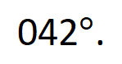 *AC* = 2.8 km and *CD* = 3.3 km.

Find

1. The bearing of *B* from *C*
2. The obtuse 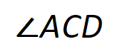
3. The distance *AD*

A vertical tower, *AT*, has its base at *A*. Given that the angle of elevation of *T* from *B* is 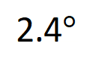 , calculate

1. The height of the tower *AT*, giving your answer to the nearest metre
2. The angle of depression of *C* from *T*